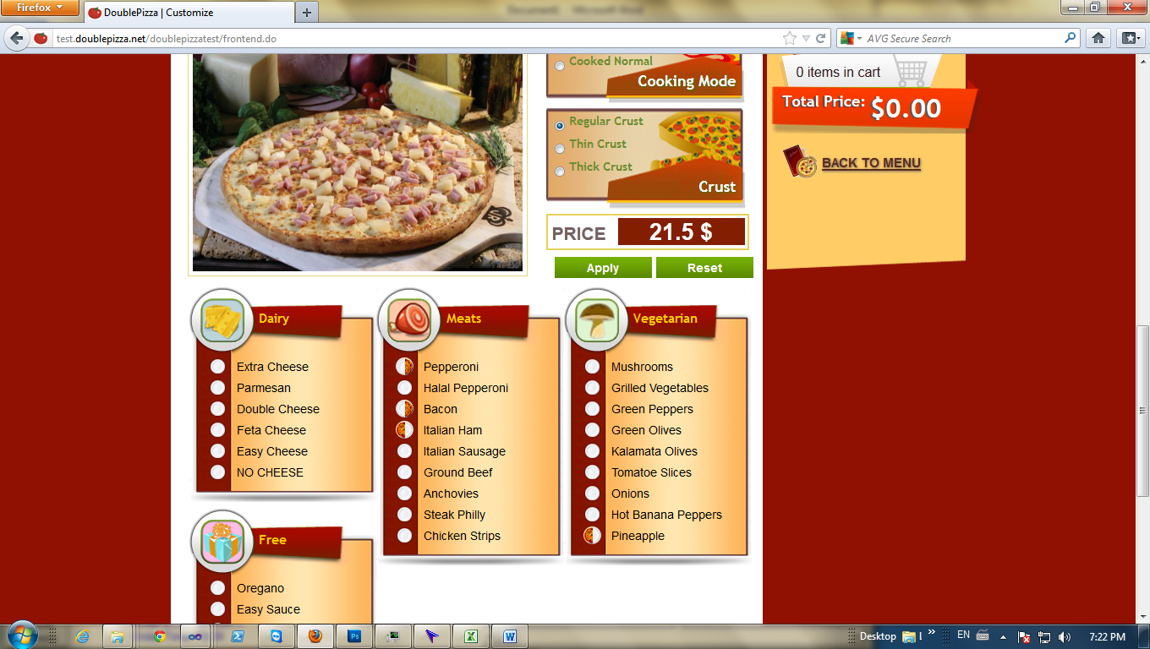

-When u make a pizza half and half its start charging over 3 toppings thinking it’s the whole pizza.

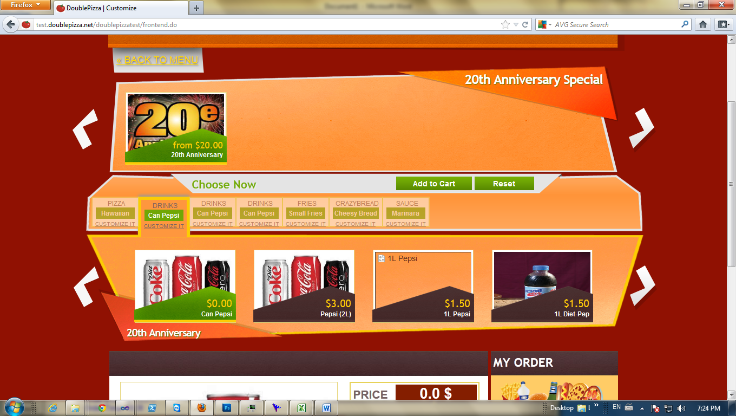

-Missing the choice of rootbeer

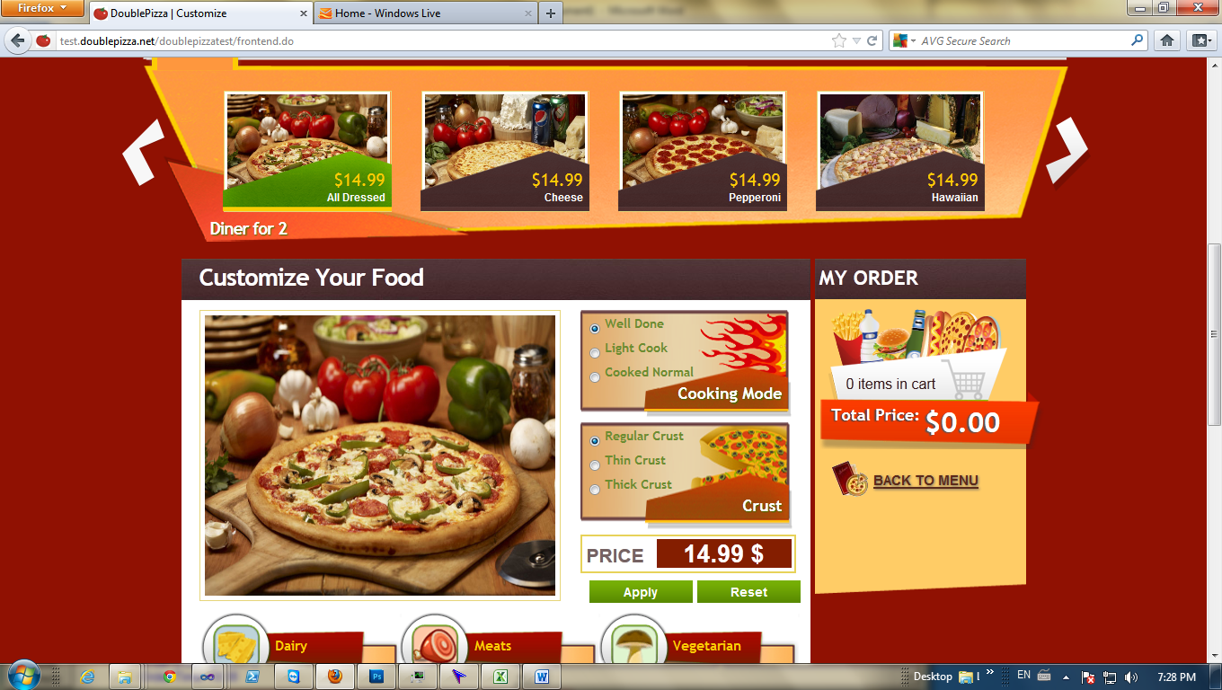

-When you make a pizza it automatically says well done, it should be cooked normal. Clients will not pay attention to this part and might not want their pizza to be well done.

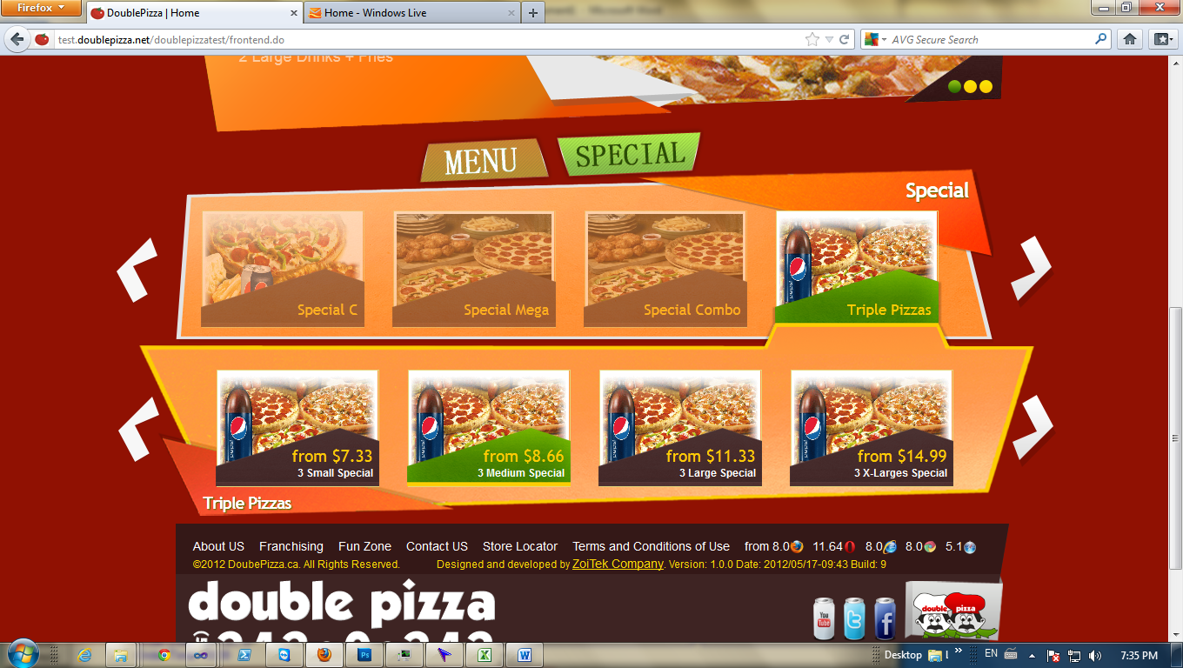

-Triple pizzas no longer have a drink with it.

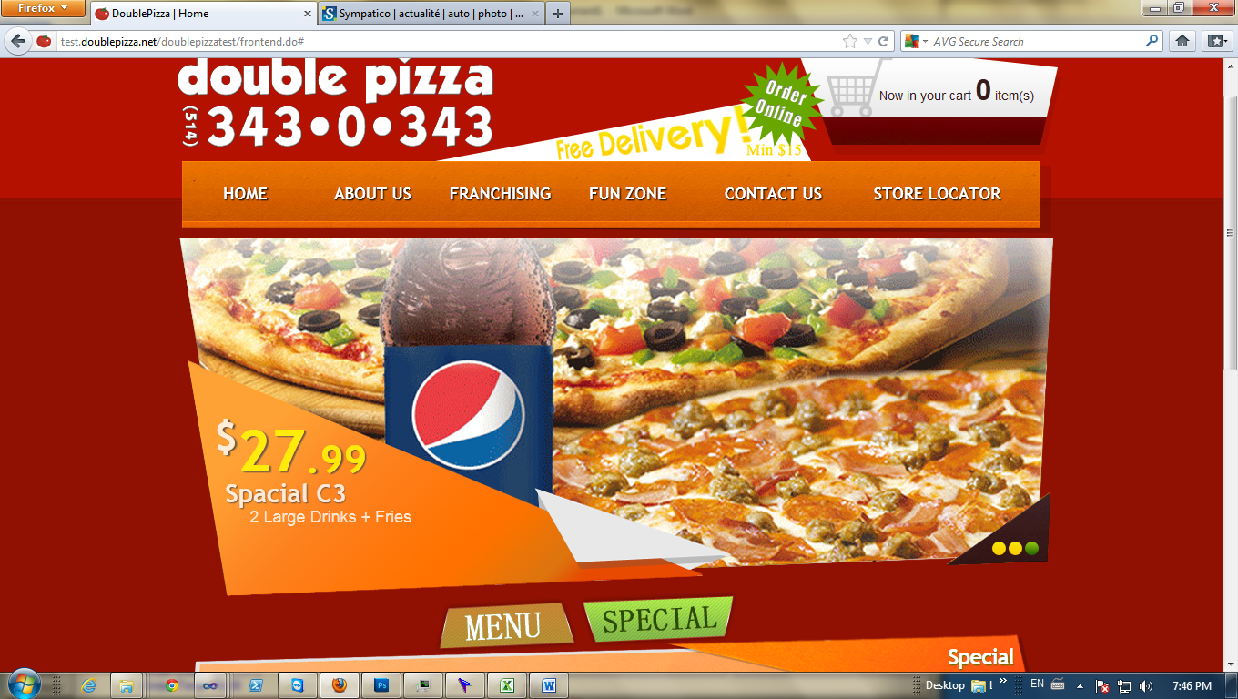

-It says 2 Large Drinks+ fries; it should be 2 large pizzas + drinks + fries

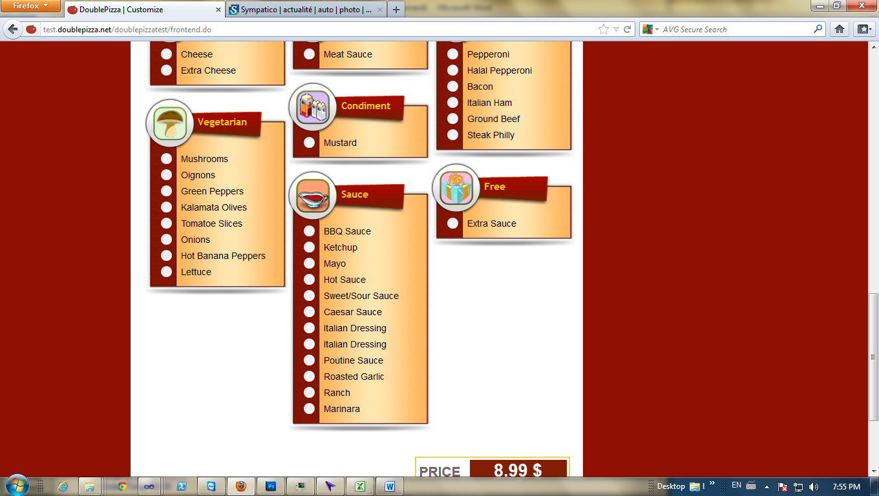

-Mayo and ketchup is condiments not a sauce.

-I made an order for pick up with a 12 inch smoked meat sub and a medium poutine, when I went to go click on the order to look at it, the system crashed. Same things goes for an order of a 12inch smoked meat sub and a garden salad. My guess is the sub is the problem.

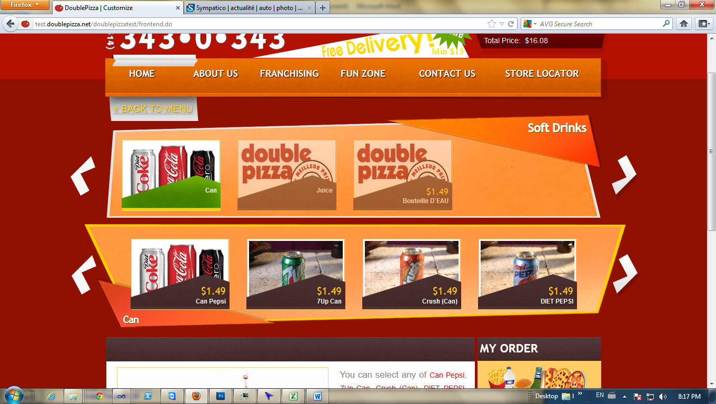

-There is no choice for 1L or 2L pepsi.

-Placed an order for a large poutine and 1 can of pepsi and system crashed when I tried to open the order.